Jerrys Plains

Public School
27-31 Doyle Street
Jerrys Plains NSW 2330
Phone: (02) 6576 4018
Fax: (02) 6576 4142
Email: jerrysplain-p.school@det.nsw.edu.au
Website: www.jerrysplan-p.schools.nsw.edu.au

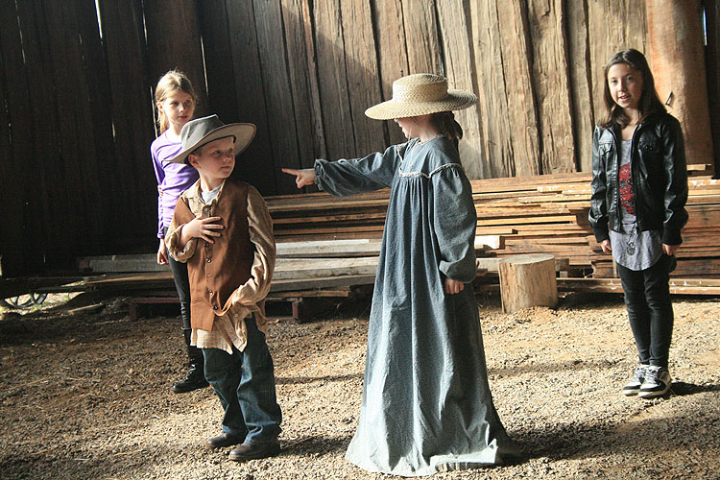
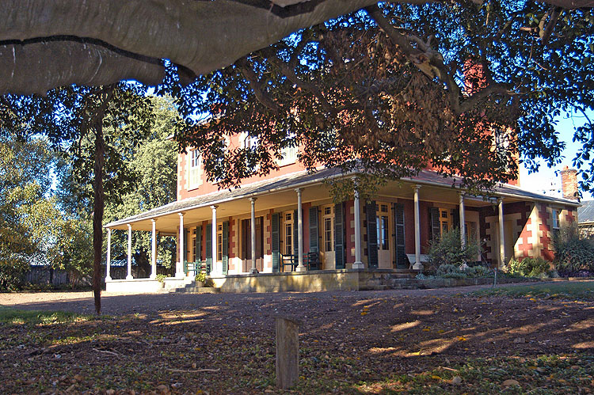

SCHOOL EXCURSION
TOCAL HOMESTEAD

Dear Parents/Carers

This year the excursion for Kinder to Year 6 will be Friday 16th September, we will be going to The Tocal Homestead.
The heritage programs are great fun and “A Study in Change’ is designed to meet the requirements of the national history curriculum.
In the heritage surrounds of Tocal Homestead, students have a hands-on experience of life on an Australian farm 150 years ago. Tocal has a range of buildings of national heritage significance where the students will learn of the heritage of the site and the lifestyles of the people who worked this farm. They will be immersed in the program which identifies the effects of changing technology over time.

Students will need to bring a packed recess, lunch and water bottle, a hat and sensible walking shoes as we will be doing a lot of walking.

Transport for this event will be by Saxby buses. We will be leaving school at 8.00 am sharp and returning approx. 3.30pm. Please make sure students are on time to school as it will be a very long day.

Please return permission slip and medical form to school by 1st July, 2016.

The cost involved is $40.00per student. Full payments are to be made by 12th September, 2016. You are welcome to make small payments up until that date.

Regina Stoltenberg
Fighter World is the only organisation authorised for on-airfield visits. An experienced Fighter World guide will escort the students on a tour of the airfield and discuss the day to day operations of a complex transport system including the role of Air Traffic Control, Airfield Rescue and Fire Fighting, refuelling operations, airfield safety and the impact of aviation transport on the environment. The students will also have time to visit Fighterworld for the chance to sit in a real jet fighter and enjoy a close up experience with some of Australia’s most famous aircraft.
Principal

TOCAL HOMESTEAD EXCURSION
16th September, 2016

I give permission for _______________________________________to attend Tocal Homestead as an excursion on Friday 16th September, 2016

I understand that transport will be by bus and the cost for the day is $40.00 per student.

I understand that my child/ren need to be at school by 7.45am for an 8.00am sharp leaving time and will be arriving back to school around 3.30pm. Parents/Carers will need to collect their child/ren from school.

Signed: _________________________________(Parent/Caregiver) Date: _________________
Personal & Medical Information Form For Excursions / Out-Of-School Activities
Student's Name …………………………………………… |  |  |  |  | Class ……….. |  | Date of Birth
Home Address |  |  |  |  |  |  | Phone
Emergency Contacts on the day
Name |  |  | Relationship |  |  | Phone (Home) |  |  | Phone (Work) |  |  | Mobile
 |  |  | ……………… |  |  | ……………… |  |  | ……………… |  |  | ……………...
 |  |  | ……………… |  |  | ……………… |  |  | ……………… |  |  | ……………...
Doctor ……………………………………….. |  | Address ………………………………………….. |  |  |  |  |  |  |  |  | Phone…...………
Medicare Number ……..…………………… |  | Private Health Fund ………..….…… |  |  |  |  |  |  |  | Number …………………….
Medical Conditions Any other relevant information eg travel sickness, ……………………………………………………...................................................................................................................................................................................................................................................................................................................................................................................................................................................................................................................................................................................................................................................................................................................................................
Tablets and Medicines | Is your child currently taking any tablets and/or medicine? YES / NO  If yes please give details…………………………………………………………………………………
Any Allergies to  Drug (eg Penicillin)  Bites/Stings (eg Bees) Or anything else | Please give details
Immunisation | Has your child had complete Tetanus immunisation? YES / NO  If yes, what was the date of the last booster? …………………………..…….
In the event of accident or illness, when it is impracticable or impossible to communicate with me, I understand the teacher in charge will arrange such medical or surgical treatment as may be deemed necessary.
If my child requires prescription, I agree to provide the school with this medication in a sealed envelope clearly labeled with my child’s name and dosage, together with written notification from your Doctor stating medication and dosage details.
Signed  (parent/caregiver) |  |  |  |  |  |  |  | Date ………………………………..

